Jeffrey A. Carmen, Ph.D.
Licensed Psychologist
Manlius, New York 13104

www.stopmymigraine.com



HEADACHE SUBTYPES

Headaches have been one of my main interests for over 20 years. Most practitioners and researchers in the headache field have personal experience with them and typically suffer from migraines, cluster headaches, or other debilitating paroxysmal forms of head pain. I don’t, which actually places me at a bit of a disadvantage. All of my personal experiences with headaches are observational.

Even though I don’t get headaches, I have collected a huge amount of clinical data. I will be sharing some of that data here (albeit from the perspective of a non-headache sufferer). The reason I am making such a strong point about personal experience is that many headaches are really difficult to describe accurately, especially in terms of intensity. Some headaches such as cluster headaches are so painful that people actually attempt suicide - not from depression but seeking pain relief. On the other end of the spectrum, milder headaches can be so mild that they may defy the assignment of any pain level. Not all headaches hurt very much. Some don’t hurt at all, which of course begs the question of whether or not to actually call them “headaches”. Migraines (generally considered headaches) come in a wide variety of subtle presentations, some presenting as transient brain malfunctions only occasionally followed by head pain. There are even categories for migraine without pain, for example: 1.21.2.3 (Typical aura without headache)

FORMAL HEADACHE CLASSIFICATION

In 1988 the International Headache Society (IHS) produced a supplement to the journal, Cephalalgia. This supplement served to define the precision with which headache professionals communicated with each other. The distinctions between headache subtypes were very detailed, although not necessarily correct. In many cases the classification system represented a best guess regarding the pathophysiology of various types of head pain. Further research has refined the understanding of headache pathophysiology, requiring subsequent restructuring of headache classification. The second edition of this classification system was revised in 2003 and published in 2004 as Volume 24, supplement 1 of Cephalalgia. This edition is more in line with current research and theory related to headache pathophysiology. Sadly, although much knowledge has been gained, we are still very far from a comprehensive understanding of headaches.

Whereas the first edition was 96 pages long, the second edition doubled in size to 160 (larger) pages. Both editions represented a monumental effort by the world’s leading headache experts. The second edition is called International Classification of Headache Disorders (ICHD-II), and is often referred to by just by those initials. This is the new authoritative reference for headache classification. I recommend it as a reference work, not as bedtime reading, although it may make a reasonable substitute for a chemical sleep aid. It should be used for formal headache research, partially because that is the classification format that journals now require.

REAL WORLD HEADACHE CLASSIFICATION

For practitioners dealing with headache sufferers in a non-research oriented setting, the ICHD-II can be used to get a rough idea as to how the headache experienced by a specific individual headache sufferer compares to the headaches described in the headache research literature. However, for the most part, by the time a headache sufferer walks into an office for assistance, the headaches have become “messy” and defy a clean diagnosis. This is where good behavioral data collection is important.

MY SIMPLIFIED VERSION OF HEADACHE CLASSIFICATION

- Have the person keep a diary. This is helpful in terms of establishing a baseline. If you are going to help someone reduce headache activity, it is a good idea to know how often head pain is present, how much it hurts, significant patterns, etc. It is surprisingly difficult to get people to actually keep a diary. Perhaps less surprisingly, diary recordings are very subjective and frequently not very precise. Still, you need some sort of baseline and a headache diary is better than no data at all.

- Diary components:

  - Day and time of onset. Individual headaches tend to have a repeating pattern. The pattern may be deceptive. Time of day may reflect rise in fall of stress patterns, but it may also reflect the length of time since the person last took pain medication.
  - Duration.
  - Day and time that the headache ends.
  - Pain levels before during and after the headache. Although the ability to discriminate an 11 point scale is not consistent with psychological research, most pain scales currently use a 0 to 10 (11 points total) point scale.
  - Mechanisms for headache relief. It is probable that the single most common headache is a kind of drug withdrawal from the drug(s) used to relieve the headache in the first place. Acetaminophen is a major offender. Since it is available over-the-counter, many people don’t consider it a drug.

- Important other variables:

  - Correlation with the menstrual cycle. Most migraine and tension headache sufferers are women of child bearing age. The probability of a experiencing a headache tends to rise and fall in relation to sex hormone shifts. A woman’s hormonal status is affected by natural hormone production, birth control hormones, and dietary hormones such as those obtained from soy products.
  - Psychological variables. These are important in making distinctions between major headache categories. The headache portion of a migraine tends to hit on release from chronic psychological tension. Tension-type headaches tend to rise in response to psychological tension and subside when the psychological tension subsides. Cluster headaches tend to have no particular connection with emotions.
  - Pathophysiology of Primary Headaches
    - Migraine headaches represent a paroxysmal neurological event. The involve a complex inter-relationship between the trigeminal nerve, the brainstem, and psychological stress responses. Also involved in the process are complex responses to external variables such as barometric pressure, and internal variables such as changing hormone states.
    - Tension-type headaches represent mechanisms that are unclear. It was once thought that they were caused by muscle tension. It is now known that muscle tension is not the cause, although there may be some increase in muscle tension in response to the pain.
    - Cluster headaches represent a largely unknown pathophysiology.
    - “Other primary headaches”. These do not clearly represent unique entities but don’t fall nicely into the first three groups.

Migraine activity is very common, and may be responsible for the origins of most of the headache patients seen in clinical practice. By the time people seek treatment the headaches tend to be complicated by medication use/overuse. It is unusual to see true cluster headaches in a clinical practice because typically the person only gets them very occasionally. Somewhat less frequently people present with tension-type headaches, but these are often misdiagnosed. They tend to be migraine headaches that have taken on a level of constancy because the person has become addicted to OTC or prescription painkillers. A “true” tension-type headache will tend to increase in intensity under stress and decrease as stress is reduced.

Based on time-of-day and psychological variables, if a headache rises slowly throughout the day and subsides at the end of the day, it is likely a tension-type headache. If the head pain doesn’t start until the end of the day when the person comes home from work or school, it is likely migraine.

Headaches that rise somewhat and fall somewhat in terms of pain, but never quite go away are very common and are very difficult to diagnose. Often they represent drug effects or drug withdrawal effects, even from medications that are being taken for reasons entirely unrelated to headaches. They may also represent a purely physiological response to an abnormal mechanism such as excessive cerebrospinal fluid pressure or chronic vascular inflammation.

Behavioral treatments such as biofeedback (peripheral thermal, EEG neurofeedback, and HEG neurofeedback) are quite effective for migraine headaches. They may be less effective for tension-type headaches unless combined with some sort of psychotherapy such as Cognitive Behavioral Therapy. Even then, they tend to be very difficult to remediate. Note: failure of a headache to respond to behavioral intervention raises suspicion that the etiology may be a secondary response to a more primary physical disorder.

EXAMPLES OF INFRARED IMAGES OF HEAD PAIN

It is nice to be able to actually see a visual correlate of the head pain. Infrared imaging allows that, at least to some extent.

There are only two types of primary headaches that I have been able to capture through infrared imaging. One is migraine, the other is sinusitis. Both types have pain that correlates with portions of the infrared image with higher head output. Note: the increased heat output may or may not reflect the actual origin of pain. The images presented here have high intensity pain located at the regions of high heat output. However this is not always the case. Some migraine headaches don’t present with a heat signature, and the infrared images of tension-type headaches look the same as for people who are not having headaches. Sinusitis images are a direct result of inflammation and hyper-perfusion, but sometimes even then, the pain is referred to other locations.

COLOR CODE FOR INFRARED IMAGES:



MIGRAINE HEADACHES IN PROGRESS:

Migraine headache, pain localized to the right temporal region. Pain level reported as “10” on a 0 to 10 point scale. Pain is reported as “pounding”. Note: migraine headaches are often reported with a “pounding” description. This raises an interesting question about pain levels. If the pain level is 10 when the headache pounds, what is the pain level between those points? Usually the person cannot differentiate between the two levels, although there is clearly a difference.

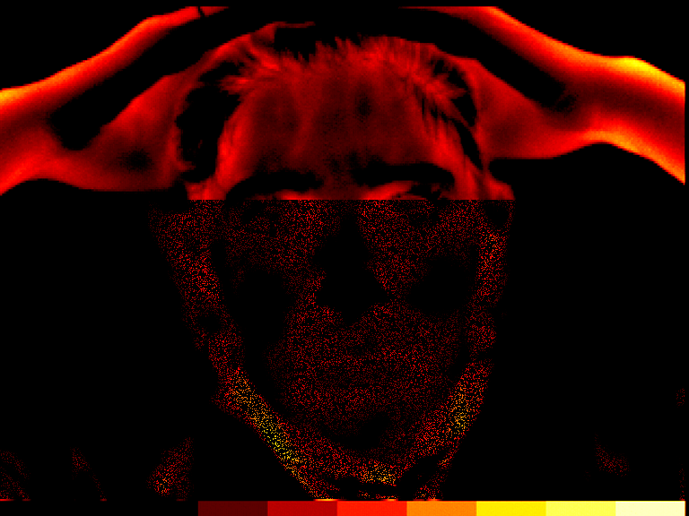

Migraine headache, pain is bilateral in the temporal regions. Pain level reported as “8 or 9” on a 0 to 10 point scale. Pain is reported as “steady”.

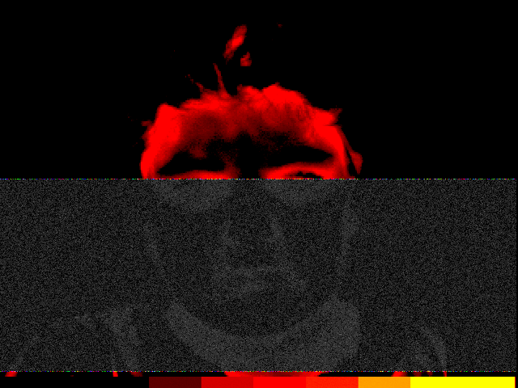

Migraine headache, left posterior. 15 year old male. Pain level reported as “10” on a 0 to 10 point scale. Pain is reported as “steady”.



SINUS HEADACHE:

Pain localized behind right eye. 55 year old female. Pain level reported as “10” on a 0 to 10 point scale. The pain is reported as “pounding”. The pain is caused by a bad right ethmoidal sinus infection, making this a “secondary” rather than “primary” headache.



SOME SUGGESTED REFERENCES

Bednarczyk, E., Remier, B., Weikert, C., Nelson, A., Reed, R. (1998). Global blood flow, blood volume, and oxygen metabolism in patients with migraine headache. Neurology, 50 (6), 1736-1740.
Breslau, N. (1998) Psychiatric comorbidity in migraine. Cephalalgia, 18 (22), 56-61.
Carmen, J. A. (2004). Passive infrared hemoencephalography: Four years and 100 migraines. Journal of Neurotherapy, 8 (3), 23-51.
Diamond, S. (1994). Head Pain: diagnosis and management. Clinical Symposia, 46 (3), 2-34.
Goadsby, P. (2001). Pathophysiology of headache, 57-72, in Silberstein, S., Lipton, R., and Dalessio, D. eds Wolff’s Headache and other Head Pain, 7th edition. New York: Oxford University Press, Inc.
Headache Classification Committee of the International Headache Society (1988), Cephalalgia, V8, supplement 7, 1-96.
Headache Classification Subcommittee of the International Headache Society (2004), Cephalalgia, V24, Supplement 1, 1-160.
Kiyaikin, E. A. (2002) Brain temperature fluctuation: a reflection of functional neural activation. European Journal of Neuroscience, 16 (1), 164-168.
Lipton, R. B., Stewart, W. F., Diamond, S., Diamond, M., Reed, M. L. (2001). Prevalence and burden of migraine in the United States: Results from American Migraine Study II. Headache. 41 (7), 646-657.
Marcus, D. (1999), Special considerations in the management of headache in women. Headache Quarterly, 10 (1), 37-43.
Mitsikostas, D., Thomas, A., (1999) Comorbidity of headache and depressive disorders. Cephalalgia, 18 (22), 22-25.
Moskowitz, M. (1998), Migraine and stroke - a review of cerebral blood flow. Cephalalgia, 18 (22), 22-25.
Sacks, O., (1992). Migraine. England: University of California Press.
Shevelev, I.A., (1992) Temperature topography of the brain cortex: Thermoencephaloscopy. Brain Topography, 6 (2), 77-85.
Shevelev, I.A., (1998) Functional imaging of the brain by infrared radiation (thermoencephaloscopy) Progress in Neurobiology. 56 (3), 269-305.
Swerdlow, B. & Dieter, J. (1991) The value of medical thermography for the diagnosis of chronic headache. Headache Quarterly, 2 (2), 96-104.
Tepper, S.J. (2001), Safety and rational use of the triptans. Medical Clinics of North America. 85 (4), 959-970.
Toomim, H., Carmen, J. (1999). Hemoencephalography (HEG). Biofeedback, 27 (4), 10-14, 27.

